The Ten Commandments of Marriage
Part 2
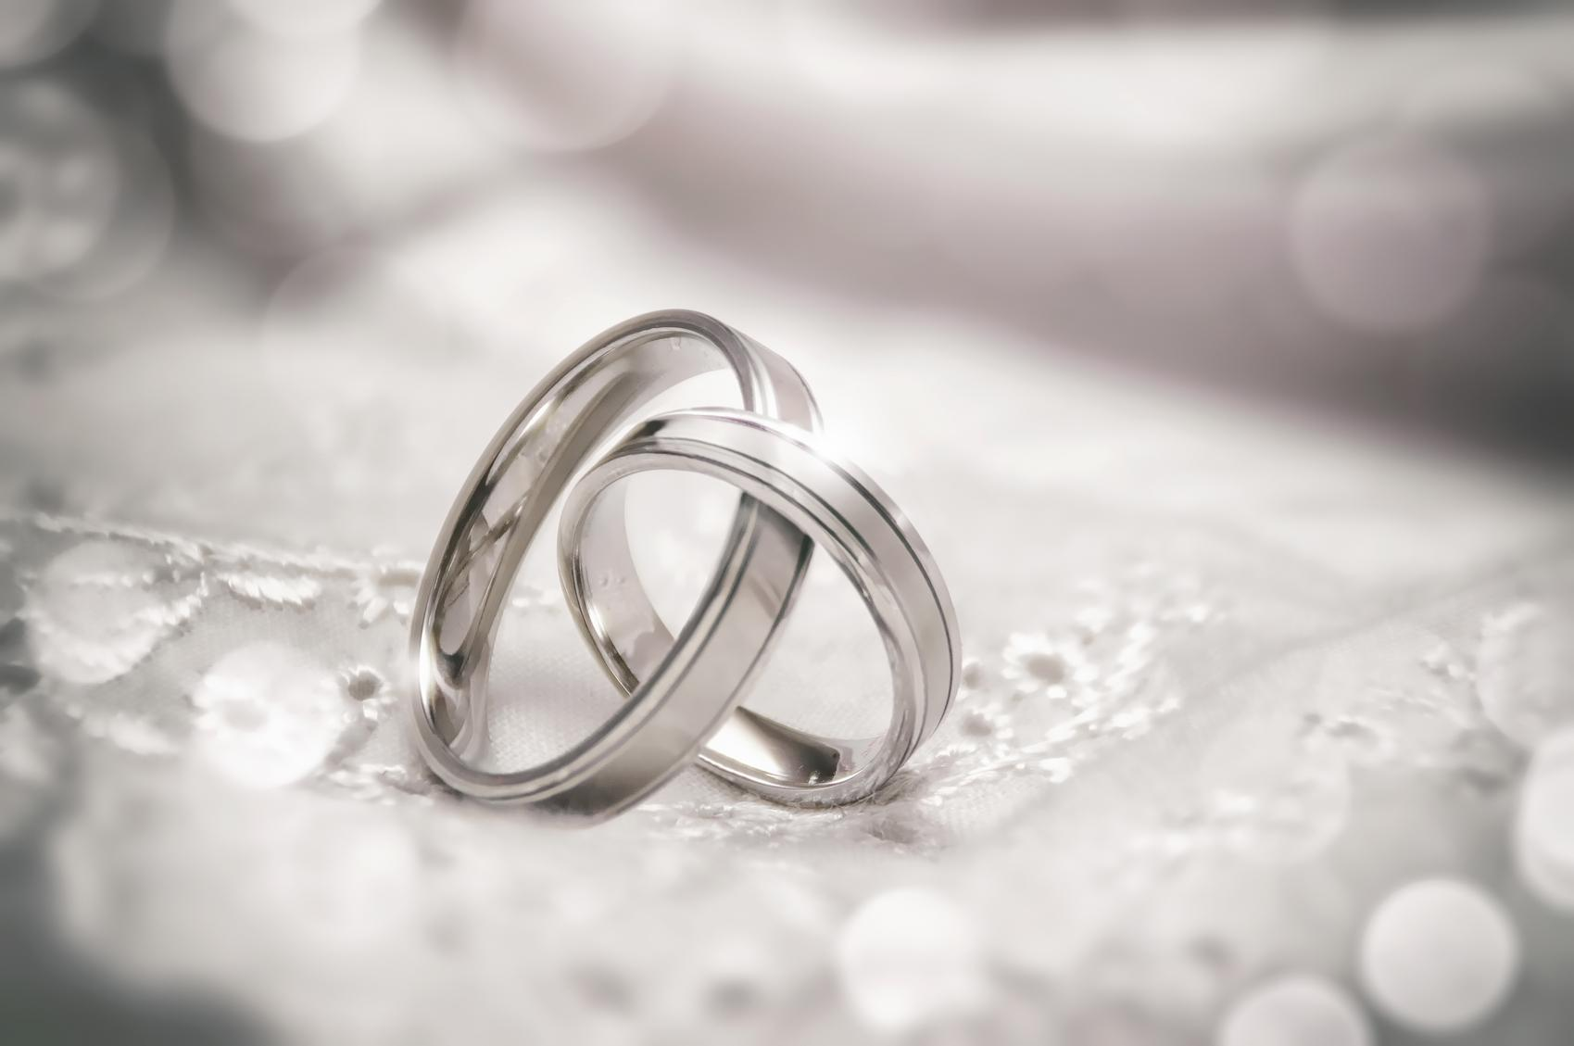

Todays’ discussion is based on Career of Happiness: True Joy in the Home, by Rabbi Avigdor Miller

The Ten Commandments of Marriage:
1 Be realistic
2 Do not disrupt the routine of marriage
3 Make peace
4 Never say the word “divorce”
5 Be loyal
6 Never say “I hate you”
7 Love your neighbor as yourself
8 Display your regard for your mate
9 Maintain your appearance
10 Don’t be a tyrant

#1
Commandment 6 - Never say “I hate you”

And never say, “You are ugly” - especially to a wife. You must maintain the imaginary situation that existed at the moment of marriage - forever and ever. Even when your wife is very old and wrinkled and toothless, make sure that you do not acknowledge any change in her appearance. Now if you wise enough to say, “You look as nice as you were when I married you”, you are going to get Olam Haba (the World to Come) for that. But under no circumstances should you even hint that there has been any change in your attitude.

Question: What if something in appearance bothers you about your spouse, should you just ignore it and pretend it doesn’t exist or try to do something about it?

How nitpicking your spouse can damage your marriage, Sheri Stritof
All long-term relationships have issues that involve personality traits or temperamental qualities that can cause perpetual conflict. These unsolvable problems are things you simply need to learn to live with.

Question: How do you “learn to live with” with things that bother you?

#2
Commandment 7 - Love your neighbor as yourself

Questions:
- Is it possible to love your spouse as you love yourself?
- What are some things you can do to make sure your love constantly grows?

Torah Bereishis 18:9
And they (the angels that came to visit Avraham) said to him, "Where is Sarah your wife?" And he said, "Behold in the tent."
Talmud Bava Metzia 87a
The ministering angels knew where our mother Sarah was, but they asked in order to make known that she was modest, in order to endear her to her husband.

Question: Avraham was known for his love to unconditional love to people and to G-d. Why did the angels feel a need to help him to love his wife more?

#3
Commandment 8 - Display your regard for your mate

If he can say in the presence of his wife to the children, or even not in her presence, “Your mother is this or that,'' he is a wicked person.

What Husbands Need to Know, Aish.com
Another tender area was the children. She often voiced her displeasure at the way I parented. She would often undermine me and refuse to back me up when I made a decision. I couldn’t understand her passive aggressive behavior, especially when it came to matters dealing with the kids.

Question: What do you think about this issue?

Rabbi Chaim Vital ( one of the great kabbalists)
A man's soul is judged in the next world according to how he treated his wife.

Question: How do you understand this statement?

#4
Commandment 9 - Maintain your appearance
Another of the ten commandments is especially for women, but also for men to some extent. Women must make it their business never to look slovenly in the house. They should always look good, smell good, and not talk too much.
Questions:
- What do you think about the common practice for women to put on makeup when they leave the house and not to have it while they are at home? What could be message behind it?
- When at home - why do you need to act like you are with others and not finally be yourself and relax?

#5
Commandment 10 - Don’t be a tyrant

Here is a man who did not trust his wife’s shopping ability. For years and years he did not allow her to go to the grocery store or butcher shop. He did the shopping himself. Among all of her friends she was the only one not allowed to shop. Her husband was a tyrant. Who cares if his wife wastes a few dollars a week? Think of it as an expenditure towards happiness.

Questions:
- What are your thoughts about it?
- How do you insure level of equality between the spouses?

#6
Question: What other “commandments of marriage” would you include to have a happy marriage?

#7
Question: What’s your takeaway from today’s discussion?

